**MANOR PARK SCHOOL AND NURSERY**

BEHAVIOUR AND RELATIONSHIPS POLICY



|  |  |
| --- | --- |
| **Responsible Person:** | Sarah Jeffery |
| **Date written:** | September 2024 |
| **APPROVED:** |  |
| **signed:** |  |
| **review DATE:** | September 2025 |

Behaviour Policy

**Our policy is based on the belief that:**

1. Positive behaviour is formed through positive relationships.
2. All children deserve to have an equal chance of success.

**Aims**

1. For staff to build effective relationships with the children, based on respect and mutual trust.
2. For staff to act as role models, co-operating and supporting one another, and treating colleagues and pupils with courtesy, consideration, and respect.
3. For staff to have a high standard of pupil expectation in all aspects of school life.
4. For staff to try to raise the levels of pupils’ self-esteem.
5. For staff to be flexible in their teaching approachestoprovide a broad, balanced and scaffolded curriculum which is both interesting and relevant.
6. To provide a supportive, learning environment that stimulates a calm, respectful, cooperative place for children.
7. To value pupils.
8. To encourage and support children in making the right choices based on the school’s 5 values
9. To implement positive reward and fair consequences systems consistently and fairly.
10. To encourage school/parental partnership, to promote children’s education and behaviour.

**Values & Expectations**

Our **Values** inform our approach and our expectations of behaviour. At Manor Park, we hold five core values at the heart of all we do. These values underpin what we believe to be important for working with each other both as pupils and as adults in later life. We use our shared values and expectations to promote positive behaviour.

Our Values are:

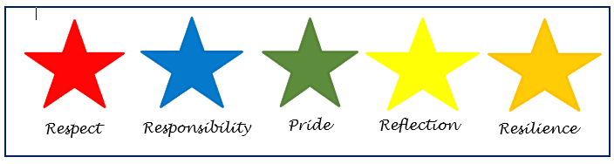

These values are shared regularly with the children and are highly visible around the school environment.

Where children are demonstrating our school values, this should be evident in their behaviour and actions around school. Staff at Manor Park expect high standards of behaviour at all times. These behaviours contribute to a positive culture of excellence and should be routinely praised by adults.

For guidance, we actively link expectations to each value with posters available as support in the classroom. (See appendix)

Some examples of expected behaviour are as follows:

|  |  |
| --- | --- |
| **Value** | **What you might expect to see** |
| **Pride** | * Displaying a positive attitude to learning * Increased self esteem * Work and behaviour of the highest standard * Giving 100% effort |
| **Respect** | * Using polite manners * Showing a readiness to learn (eyes on the learning, listening carefully, facing the speaker) * Moving around school sensibly and quietly * Caring for both other children and school equipment |
| **Responsibility** | * Tidying away equipment neatly * Holding open doors for others * Presenting work to a high standard * Helping younger children around school * Bringing in Home Learning books and Reading Diaries on the correct day |
| **Resilience** | * Trying something difficult or challenging * Attempting to solve problems independently * Working with adults to make corrections or improvements * Willingness to share mistakes and learn from them |
| **Reflection** | * Acting on feedback given * Trying something new * Having ownership over their learning * Embedded skills like remembering, questioning, investigating, explaining, sharing, and revisiting |

**Praise, Motivation and Reward**

It is very important that praise and reward should have great emphasis. Children will achieve more, be motivated and behave better, when staff commend and reward their successes. **Praise** has a reinforcing and motivational role. It helps a child believe they are valued. Praise can be delivered in formal and informal ways, in public or in private; it can be awarded to individuals or to groups; it can be earned for the steady maintenance of good standards as well as for particular achievements.

By maintaining the importance of our values and through seeing them lived in our school, children will feel motivated to engage in positive behaviour and action. We instil value and encourage the growth of a child’s own **intrinsic motivation** in the following ways:

* Clear, regular **praise** and encouragement from adults as the primary way of motivating pupils.
* **Positive relationships** with children enable staff to give meaningful and impactful praise when a child demonstrates a value in our school.
* Verbal or written **feedback** is given throughout lessons to indicate successful completion and attitude towards learning tasks (see Feedback Policy).
* Children’s work should be displayed throughout the school environment
* A visit to the Leadership Team for commendations and further praise may be given.
* Post cards home to celebrate achievements and behaviour (2 per week per class)

Where children’s behaviour is particularly exemplary or noteworthy, adults may reward children to further encourage positive behaviour, effort and manners.

**House Points**

* + Children may be awarded a House Point when they display behaviour promoting one of our school values. Rather than individual, these points contribute to a class total where all children in a class strive to add to the same tally of points. This links to our work on children working together towards a common goal of excellence, rather than individual merit.
  + House points will be added to a visual house point container every week. Once a half term the house points will be weighed and the winning house will receive a non-uniform day at the start of the new half term.
  + The weights will be recorded half termly with the house with the most points at the end of the year achieving an additional reward.
  + Only one House point can be awarded at a time. Once a house point is awarded it can never be deducted.

**Team Rewards**

* Each class team will have a team reward system which the children can collectively contribute towards.
* This may be something like marbles in the jar etc
* This will result in a half termly team reward if collectively it has been achieved.

**Achievement Assembly**

A weekly ‘Celebration’ assembly is dedicated for the praise and recognition of children who have made particularly noteworthy contributions to our school values. Value awards are awarded to those children who are recognised as having displayed the focus value during the week. One award will be presented per class per week.

* Example of certificate message:
  + *James _____ - For showing responsibility when helping a friend at lunch time.*
  + *John _____ - For his pride in the presentation of his work*
  + *Jess _____ - For listening carefully in lessons. Great manners and respect!*

**Teams**

At Manor Park Primary School and Nursery, we believe that our classrooms embody team qualities such as democratic leadership, cooperation, teamwork, equality, fairness, trust and strong personal relationships. Within the classroom teams, everyone feels valued and has a role to play. We see our teams as one big family whereby every child feels comfortable and confident to flourish.

The simple fact is children feel safest, happiest and actually learn the best when they live and operate as part of a team.

**Enabling Positive Behaviour**

To enable a climate and culture of positive behaviour at our school, all staff must model high standards of behaviour and courtesy. Teachers will identify and praise examples of excellent behaviour in children and use these to support pupils where behaviour is not meeting the school’s expectations.

**Positive relationships with children** are at the heart of good behaviour. By making strong professional bonds with our pupils and creating a climate of support, trust and understanding, we as educators can positively influence behaviour and ensure all children know how to act in school every day.

**Forming Positive Relationships**

* Establish **clear roles and boundaries** with pupils. Where teachers form relationships with a focus on supporting learning, adults and pupils can work together towards this common goal.
* **Communicate kindness** through all interactions with children. When things are said or the way they are said is kind, this influences the relationship in a positive way. Kindness should be at the forefront when dealing with any challenging situation. Get to know the children, so you can demonstrate you are interested in them as individuals.
* Strive to be both **assertive and warm** with children. Though there is an expectation that pupils follow the direction of the teacher, tone of voice and body language move this from acts of compliance to collaboration through respect.
* Behaviour may prove challenging, but adults must **remain professional** throughout. Remaining calm and rational is important, as well as framing issues positively.

**Positive Behaviour Through Choice and Consequence**

When interacting with children, we use a hierarchy of steps to promote a positive culture of standards and behaviour in our school. These impact how we deal with behaviour incidents across the school. In the vast majority of examples, the first two steps in this process should be sufficient in dealing with disruptive behaviour both in class and around school. Where this is not the case, teachers should choose a consequence in response to the behaviour. The consequence will be fair to the action and in line with the policy. It will also be based on the educator’s knowledge of the child. The consequence will support the child in making better choices. It should not be in public, but in a private space - this may be a quiet talk in an area of the classroom or outside the classroom.

1. **Expect Positive Behaviour**
   1. Set a positive tone by praising the behaviour you want to see rather than pointing out the unwanted behaviour. In a majority of cases, clear mention of the correct behaviours linked to warm praise is enough to encourage children’s behaviour choices to change.
   2. **Examples:***Excellent James, you’re showing me wonderful sitting.  
      Fantastic listening today, class.  
      I can see that Jess is ready because her pencil is down, well done.*
2. **Use Assertive Direction**
   1. If behaviour does not change, a child may need the correct behaviour to be identified for them clearly. Though assertive, this should be viewed as a supportive correction and not a criticism or challenge to a child. This is an opportunity to further identify the behaviour we want to see.
   2. **Examples:***James, please put your hand up if you would like to share with the class.  
      Please sit nicely class so the others behind you can see.  
      Can you come with me Jess? Then we can talk about why you are upset. Thank you.*
3. **Identify Choices**
   1. In order for children to take ownership of their behaviour, both positive and negative, identifying the choice children are making versus a better choice gives the child the opportunity to correct their actions before a consequence is needed.
   2. **Examples:***James, please let’s talk so I can help you in your decision making.   
      John, sitting nicely as I have asked is the right choice to help everyone to learn.  
      Jess, by choosing to shout out you are disrupting our learning. Raising your hand as I have asked is the right choice to share your thinking.*
4. **Narrate the Consequences**
   1. Where unwanted behaviour persists and a better choice is not made, a clear, proportional consequence should be explained to the child. Failure to correct the behaviour has resulted in the consequence being carried out. Consequences should always be carried out – certainty of consequence is more important than the severity. This stage must be discussed in private.
   2. **Examples:***James, by choosing to talk when I have asked you to listen you have stopped yourself and other learning. This means you need to have a consequence; I think x is fair do you agree?*

(See appendix for Choice and Consequence posters which provide a guide and can be displayed in the classroom).

**Consequences**

In the use of consequences, pupils learn from experience to expect fair and consistently applied consequences which are a fair response to the action. The consequences should be applied through discussion with the child and the teacher must still remain calm, fair and understanding.

**Escalation**

If a behaviour continues to occur and there does not appear to be a change in the behaviour then staff should remind the child that they will miss 5 minutes of their break/lunch time to complete a consequence sheet and think about the different choices they could have made. It is the responsibility of the class teacher to initiate this in the first instance.

If behaviours continue, staff should seek additional support and guidance from the Pastoral Team regarding alternative strategies.

If this support has been requested from the Pastoral Team, the behaviour needs to be recorded on CPOMS, so a pattern can be identified.

**Speak to Parents**

We are committed to maintaining open and honest communication with parents regarding their child's behaviour. As part of this, we have implemented the following steps to keep parents informed and to support children in improving their behaviour.

**Five Consequences in a Half Term**

Once a child has completed five consequence sheets within a half term, the class teacher will contact the parents to inform them. At this point, the child will also have a meeting with the head teacher to discuss their behaviour.

**More than Five Consequences in a Half Term**

If a child exceeds five consequences in a half term, they will need to meet with the head teacher again. In addition, parents will be contacted for each additional consequence received. The Pastoral team will also be involved to provide further support to the child.

**Ten Consequences in a Term (Two Half Terms)**

Should a child receive ten consequences over the course of a term, a formal meeting with the parents will be arranged. During this meeting, the child will be placed on a structured behaviour chart with up to three specific targets.

The child will remain on this behaviour chart until one of the following is achieved:

* They complete three consecutive weeks with no more than two missed ticks in any week,
* Or they begin a new half term, which will mark a fresh start for their behaviour.

Our aim is to ensure that children receive the necessary support to improve their behaviour while keeping parents fully informed and involved in the process.

**Suspension and Exclusion**

For the vast majority of pupils, suspensions and permanent exclusions may not be necessary, and their behaviour can be managed by other strategies. However, if approaches towards behaviour management have been exhausted, then suspensions and permanent exclusions will sometimes be necessary as a last resort. This is to ensure that pupils are protected from disruption and can learn in a safe, calm and supportive environment.

Serious incidents will to be treated on an individual basis and the circumstances investigated.

In exceptional circumstances permanent exclusion may be considered for a first or ‘one off’ offence. These may include:

* Serious actual or threatened violence against another pupil or a member of staff;
* Sexual abuse or assault;
* Supplying an illegal drug;
* Carrying an offensive weapon;
* Serious deliberate damage to school property.

For further information on suspensions and exclusions please see our Suspension and Exclusion Policy.

**Children who need additional support**

The school acknowledges that a small minority of children may for whatever reason lack the maturity or self-discipline to make the correct choices available to them in order to control their own behaviour. This may be especially true of children with or being assessed for EHCP and those in care. For these children neither the normal rewards or consequences procedures may be sufficient to support them or protect other children from their actions.

In these exceptional circumstances the school will make every effort to avoid exclusion. It is vitally important that parents are informed and involved when behaviour targets are agreed in order to establish possible causes and form a partnership of support.

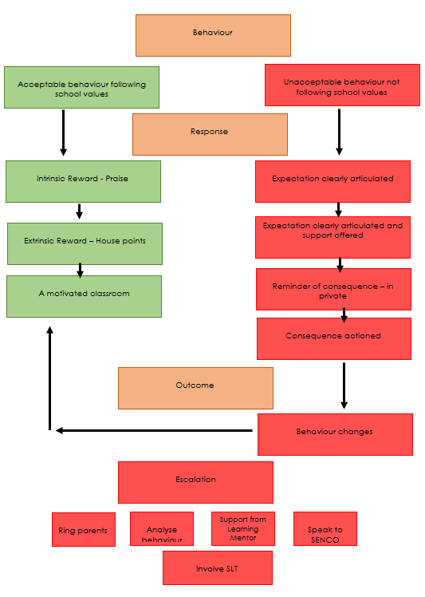

|  |
| --- |
| **Reflection** |
|  |
| You can show reflection in lots of ways:   * Acting on feedback given * Trying something new * Having ownership over their learning * Embedded skills like remembering, questioning, investigating, explaining, sharing, and revisiting |

|  |
| --- |
| **Pride** |
|  |
| You can show pride in lots of ways:   * Displaying a positive attitude to learning * Believing in yourself * Work and behaviour of the highest standard * Giving 100% effort |

|  |
| --- |
| **Responsibility** |
|  |
| You can show responsibility in lots of ways:   * Tidying away equipment neatly * Holding open doors for others * Presenting work to a high standard * Helping younger children around school * Bringing in Home Learning books and Reading Diaries on the correct day |

|  |
| --- |
| **Respect** |
|  |
| You can show respect in lots of ways:   * Using polite manners * Showing a readiness to learn (eyes on the learning, listening carefully, facing the speaker) * Moving around school sensibly and quietly * Caring for both other children and school equipment |

|  |
| --- |
| **Resilience** |
|  |
| You can show resilience in lots of ways:   * Have a go at something difficult or challenging * Try to solve problems by yourself * Work with adults to fix and improve things * Share mistakes and learn from them |

|  |  |
| --- | --- |
| **Choice and Consequence** | |
| **Be the best** | **BE A TEAM PLAYER** Take care of yourself,  Take care of each other,  Take care of the environment.  Ask your teacher when you need help. |
| **Listen and respond** | **LISTEN TO THE ADULT**  When you’re not making the right choices, listen to the adult.  They will help you make the right choice. |
| **Make the right choices** | **MAKE THE RIGHT CHOICE**  Let the adult help you to change your behaviour so you are making the right choice.  They may take you out of the classroom for this. |
| **Accept the consequence** | **CONSEQUENCE**  When the adult asks you to change your behaviour it is to help yourself, each other and our environment.  If you don’t make the right choice, you and the adult will choose a fair consequence. |

|  |  |
| --- | --- |
| **Choice and Consequence**  **The impact of positive and unwanted behaviours should be discussed with your classes as needed to embed a ‘Team’ classroom. Possible consequences can be discussed during these class discussions to lay out clear expectations.**  **The consequences of the children’s unwanted behaviours are set through discussion between the child and their trusted adult (this will be the adult who has supported them throughout the incident).** | |
| **Be the best** | **SET HIGH EXPECTATIONS IN YOUR CLASSROOM.**   * Embed the school values. * State what you want to see, be clear that not following the school values will result in a consequence. |
| **Listen and respond** | **ASSERTIVE DIRECTION**   * Explain what change of behaviour you want to see. * Be clear, consistent and fair |
| **Make the right choices** | **SUPPORT CHANGE**   * Support the child in taking ownership of their choices. * State your expectations and give the reason for what you are asking. * Give time for them to process and change their behaviour. |
| **Accept the consequence** | **CONSEQUENCE**   * Move the child away from the situation, discuss their behaviour. * Support them in understanding their behaviour. * Explain why it is not suitable. * Agree a fair consequence – usually missing 3 minutes of break time. |