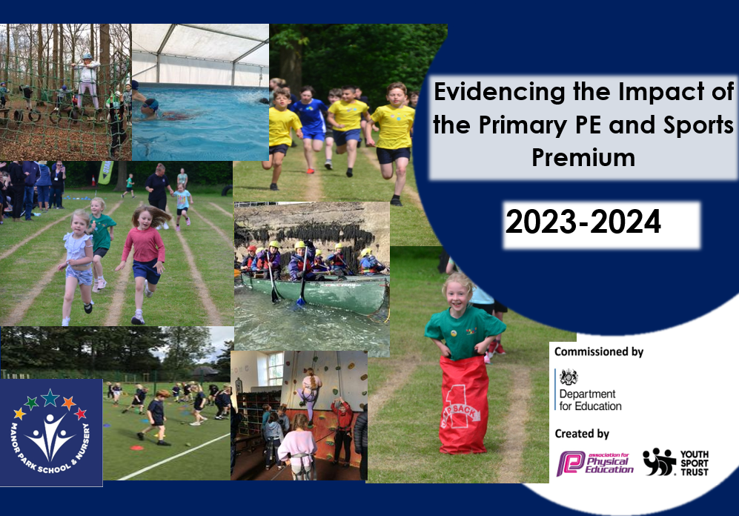

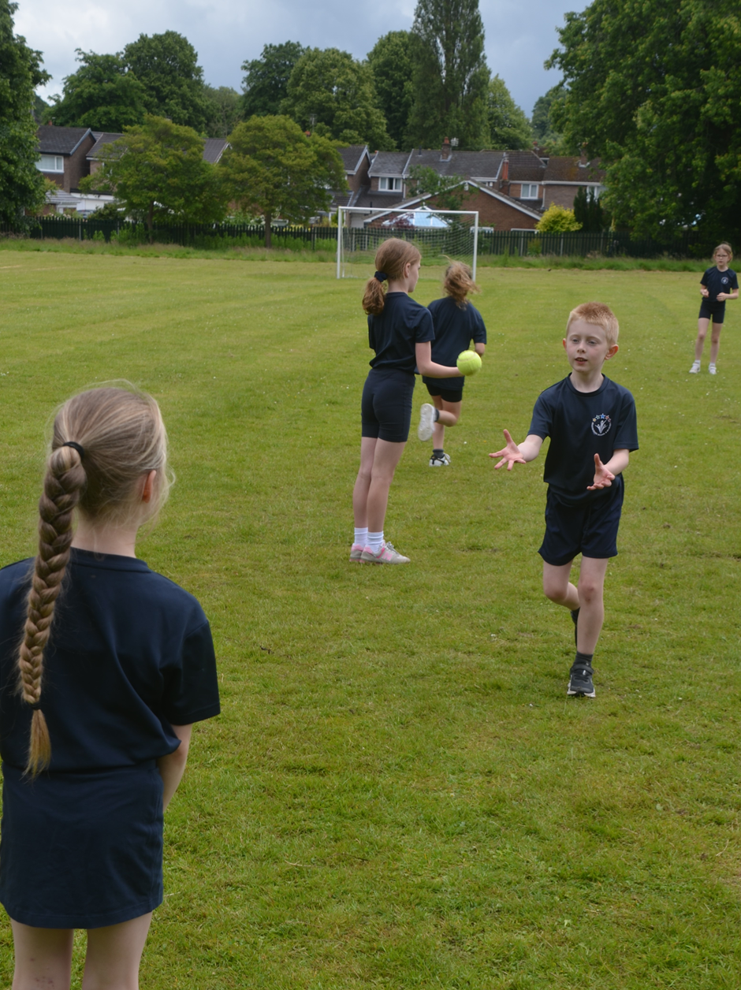

**Schools must use the funding to make additional and sustainable**

**improvements to the quality of the PE, School Sport and Physical Activity (PESSPA)**

**they offer. This means that you should use the Primary PE and sport premium to:**

**• Build capacity and capability within the school to ensure that improvements made now will benefit pupils joining the school in future years**

**• Develop or add to the PESSPA activities that your school already offers.**

**The Primary PE and sport premium should not be used to fund capital spend projects; the school’s core budget should fund these. Further detail on capital expenditure can be found in the updated Primary PE and sport premium guidance.**

**The Primary PE and sport premium guidance, outlines 5 key priorities that funding should be used towards. It is not**

**necessary that spending has to meet all the key priorities, you should select the priorities that you aim to use any funding towards.**

**Although completing this template is not a requirement for schools, schools are required to publish details of how they spend this funding. Schools must also outline what the impact this funding has had on pupils’ PE and sport participation and attainment and how any spending will be sustainable in the future. All funding must be spent by 31st July 2024.**

**The Department for Education has worked closely with the Association for Physical Education (afPE) and the Youth Sport Trust (YST) to develop this template and encourages schools to use it. This template is an effective way of meeting the reporting requirements of the Primary PE and sport premium.**

**Manor Park Primary and Nursery School –**

**Primary PE and Sports Premium Review and Plan 2023 - 24**

|  |  |
| --- | --- |
| **Key achievements to date:** | **Areas for further improvement and baseline evidence of need:** |
| The successful continued improvement of the environment and resources in collaboration with OPAL at Manor Park - OPAL is an award-winning, mentor supported school improvement programme that addresses all the areas that schools must plan for if they want to strategically and sustainably improve the quality of their play opportunities.  Pupils participated in a wide range of PE provision led by highly trained and competent staff members and coaches.  Wider opportunity for children to take part in sporting competitions.    The use of external experts for cricket and tennis has enhanced the sporting offer in PE for all children.  Teaching and support staff worked alongside expert sports coaches to develop subject knowledge - ASM  Extensions to the outdoor trim trail, climbing walls and OPAL provision.  Continued collaboration with KMAT looking forward to participating in competition with local schools including, Cross Country for KS2, Hockey, Dance, Football Tournaments, Sports Hall Athletics, Multi-skills, Rounders Tournament and KS2 Cricket taster event | Continued investment to ensure growth of resources and equipment for OPAL  Define and further develop means of assessment within PE, including a focus on pupil-engaged assessment  Ensuring all children are given access to the highly popular, newly introduced sports currently offered in before and after school clubs.  Familiarise and begin to use the portal system provided by ASM for assessment.  Continue to improve children’s skills in P.E. lessons so we can perform even better in KMAT competitions.  Identify children who do not fully engage in PE and the potential barriers. Enable full inclusion and participation of children in line with the school improvement plan.  Have a higher number of disadvantaged children undertaking sport clubs and competitions.  Wider range of sporting coaches coming to school |

**Key priorities and Planning**

|  |  |  |  |  |  |
| --- | --- | --- | --- | --- | --- |
| **Academic Year: 2023/2024** | | **Total fund allocated: £17,950** | | | **Date Updated: July 2024** |
| **Key indicator 1: The engagement of all pupils in regular physical activity – Chief Medical Officer guidelines recommend that primary school children undertake at least 30 minutes of physical activity a day in school** | | | | | |
| **Action** | **Funding** | **Impact and Evidence** | | **Next Steps** | |
| To ensure all children are  Accessing physical activity (in  addition to their 2 hours of PE lessons per week) in school. |  | PE lessons twice weekly and play times. OPAL continues to help greatly with this – the tyres,  den building, scooters , sandpit, crawling tunnels, slack lines and  trampoline continue to encourage children who aren’t  interested in playing football to be active.  Trim trail and Spinney | To monitor and target children (particularly in UKS2) who are not fully engaged in leading healthy  and active lifestyles, especially at break, lunch times and after school.  Improving the quality of playtime through school grounds developments to target children less enthused by competitive  sports. | | |
| To continue to improve and ensure growth of the OPAL scheme to enhance play and physical activity during break and lunchtimes. Scooters, beach hut, beach provision, trampoline  To train playleaders to actively promote and support the OPAL initiative | £8449 | Children all accessed enhanced playground resources as observed  during playtime monitoring. | Ensure that all outdoor equipment is kept in good condition and that new resources are purchased where needed. | | |

|  |  |  |  |  |
| --- | --- | --- | --- | --- |
| **Key indicator 2: The profile of PE and Sport being raised across the school as a tool for whole school improvement** | | | | |
| **Action** | **Funding** | **Impact and Evidence** | | **Next Steps** |
| To improve the profile of PE across the school by celebrating  Achievements in whole school  assemblies. | £2971 - the electrical installation for the pool which will be used next year. | Children have been able to access a wide range of expert-led  after school clubs.  Sporting achievements have been able to be celebrated and shared in assemblies. Children have been able to be proud of what they have achieved and children have been encouraged by their peers. This has been as a result of the  school’s participation in the events and competitions this year.  Newsletter updates, social media posts and school assemblies continued to raise the profile of PE and encourage participation and improvement. | To continue and to increasingly use social media / newsletters to  promote the profile of P.E. with parents and the local  community.  Promote and encourage  children to take part in the  Knutsford academy events  that run throughout the year.  To continue the broad  range of popular after school clubs, with an emphasis on KS1 so children at a younger age  can become involved in a  range of sports and carry this on throughout their time at Manor Park. | |
| Children to continue to have access to the school Sports kit as required for external sporting events. | £435 | Children who represent the school use the kit and look exceptionally smart. Having the kit raises their self-esteem and well-being. | Replace and update as required | |
| **Key indicator 3: Increased confidence, knowledge and skills of all staff in teaching PE and sport** | | | | |
| **Action** | **Funding** | **Impact and Evidence** | | **Next Steps** |
| Use of expert sports coaches to ensure that pupils are increasing their subject knowledge and confidence through  observation.  CPD offered to staff regularly during PE sessions by PE leads, with team teach opportunities taking place to improve the quality of PE offered to the children. | £5920 | By observing other coaches invited into school, teachers are building up a repertoire of skills to successfully teach PE. | Our next steps are to promote the range of sports we offer and to ensure children are experiencing a range of sports. | |
| **Key indicator 4: Broader experience of a range of sports and activities offered to all pupils** | | | | |
| **Action** | **Funding** | **Impact and Evidence** | | **Next Steps** |
| For children at Manor Park to  Experience outstanding P.E.  lessons provided by both our sports coach and their class teacher. The curriculum is  progressive, broad and balanced from EYFS to Year 6 and additional sports and activities are offered as after school clubs. |  | The range of activities this year has been increased, and the participation has increased,  but also there have been more events for the younger year groups. | Our next steps are to promote the range of sports we offer and to ensure children are experiencing a range of sports. | |
| **Key indicator 5: Increased participation in competitive sport** | | | | |
| **Action** | **Funding** | **Impact and Evidence** | | **Next Steps** |
| Remain invested in the KMAT partnership with other local primary schools. | £1375 | Children are given the opportunity to compete against other children within their own year group.  More events and clubs for the younger year groups – the calendar, the events and the clubs were not just dominated by Y5 and Y6. | We will promote and encourage  more children to compete in the  competitions. Many of the  children will be learning the sports in their P.E. lessons before being offered the opportunity to  participate in the after-school  events. | |

**Swimming Data**

*Meeting National Curriculum requirements for swimming and water safety.*

*Priority should always be given to ensuring that pupils can perform safe self-rescue even if they do not fully meet the first two requirements of the National Curriculum programme of study*

|  |  |  |
| --- | --- | --- |
| **Question** | **Stats:** | **Further context**  **Relative to local challenges** |
| What percentage of your current Year 6 cohort can swim competently, confidently and proficiently over a distance of at least 25 metres? | 80% |  |
| What percentage of your current Year 6 cohort can use a range of strokes effectively [for example, front crawl, backstroke, and breaststroke]? | 80% |  |

|  |  |  |
| --- | --- | --- |
| What percentage of your current Year 6 cohort are able to perform safe self-rescue in different water-based situations? | 25% |  |