**MANOR PARK SCHOOL AND NURSERY**

**ATTENDANCE POLICY**



The Attendance Policy in respect of Manor Park Primary School has been discussed and adopted by the Governing Body

Last updated: September 2024

To be reviewed: September 2025

Attendance Policy

|  |  |
| --- | --- |
| **PERSON RESPONSIBLE FOR POLICY:** | Sarah Jeffery |
| **APPROVED:** |  |
| **signed:** |  |
| **to be reviewed:** | September 2025 |

**Statement of intent**

The Governors and staff at Manor Park Primary School and Nursery are united in their belief that regular school attendance is the key to enabling children to maximise the educational opportunities available to them. Helping them to become emotionally resilient, confident and competent adults who are able to realise their full potential and make a positive contribution to their community.

All children of compulsory school age have the right to an efficient full-time education, regardless of age, aptitude, ability and any special needs s/he may have. Regular school attendance is essential if a child is to make the most of the educational opportunity available to them.

Manor Park takes seriously its responsibility to monitor and promote the regular attendance of all its children. It acknowledges that irregular attendance seriously disrupts continuity of learning, undermines educational progress, can lead to underachievement and low attainment and impedes the child’s ability to develop friendship groups within school.

This policy seeks to ensure that all stakeholders involved in the practicalities of school attendance are aware and informed of attendance matters in school and to outline the school’s commitment to attendance matters.

It details the responsibilities of individuals and groups involved and the procedures in place to promote and monitor pupil attendance.

**Legal framework**

This policy has due regard to legislation and statutory guidance, including, but not limited to, the following:

* Education Act 1996
* Equality Act 2010
* Education (Pupil Registration) (England) Regulations 2006 (As amended)
* Children (Performances and Activities) (England) Regulations 2014
* Children and Young Persons Act 1963
* DFE (2024) ‘Working together to improve school attendance’
* DfE (2015) ‘Child performance and activities licensing legislation in England’
* DfE (2024) ‘Keeping children safe in education’
* DfE (2024) ‘Children missing education’

**A whole school approach to supporting attendance at Manor Park**

Securing good attendance at Manor Park cannot be achieved in isolation, and effective practices for improvement will involve working closely with other Leaders within the school. The Attendance Leader will work alongside the Curriculum Leaders, Behaviour Leader, SENDCo and Pupil Premium Leader to facilitate a whole school approach.

**The Strategic Approach**

Manor Park Primary School and Nursery adopts the 5 Foundations of Effective Attendance Practice framework which is modelled on the work of Professor Katherine Weare. The emphasis is on developing a school culture and climate which builds a sense of connectedness and belonging to ensure all children can attend school and thrive. The approach ensures we prioritise building solid working relationships with children, and parents, prior to escalation. The staged approach we follow ensures we identify triggers early that can lead to poor attendance issues such as mental health issues, lack of trust, communication and relationship breakdowns and the possible lack of networking opportunities both internal (in-school) and external (external agencies).

**Aims**

This attendance policy ensures that all staff and governors in our school are fully aware of and clear about the actions necessary to promote good attendance.

 Through this Policy we aim to:

* Increase school Attendance and reduce Persistent Absence to meet set targets.
* Ensure Attendance is well managed within the school, with the appropriate level of resources allocated.
* Enable the school to make informed use of attendance data to target interventions appropriately,

focusing on the key demographic groups highlighted in the 2022 DFE attendance paper

* Achieve a minimum of 96% attendance for all children, apart from those with chronic health issues.
* Raise awareness of parents, carers and children of the importance of uninterrupted attendance and punctuality at every stage of a child’s education.
* Ensure that our policy applies to Nursery and Reception aged children in order to promote good habits at an early age.
* Promote a positive and welcoming atmosphere in which children feel safe, secure, and valued, and encourage in children a sense of their own responsibility.
* Recognise the key role of all staff, but especially class teachers, in promoting good attendance.

**Objectives**

* create an ethos within the school in which good attendance is recognised as the norm and every child aims for excellent attendance.
* make attendance and punctuality a priority.
* set focused targets to improve individual attendance and whole school attendance levels.
* embed the 5 Foundations of Effective Attendance Practice framework which defines agreed roles and responsibilities and promotes consistency in carrying out designated tasks with respect to promoting attendance and punctuality.
* record and monitor attendance and absenteeism and apply appropriate strategies to minimise absenteeism.
* develop a systematic approach to gathering and analysing relevant attendance data.
* provide support, advice and guidance to; parents, children and develop mutual cooperation

between home and the school in encouraging good attendance and in addressing identified

attendance issues.

* Demonstrate that the school recognises good attendance and punctuality are achievements in themselves.

**Definitions**

**Authorised absence**

An absence is classified as authorised when a child has been away from school for a legitimate reason and the school has received written notification from a parent or carer.  For example, if a child has been unwell and the parent telephones the school to explain the absence, we consider that to be a first point of contact. This needs to then be followed up by written notification for the absence to be authorised.

Only the school can make an absence authorised.  Parents do not have this authority. Consequently not all absences supported by parents will be classified as authorised.

**Unauthorised absence**

An absence is classified as unauthorised when a child is away from school without the permission of the school.

Therefore the absence is unauthorised if a child is away from school without good reason, even with the support of a parent. An “unauthorised absence” can be:

− Parents keeping children off school unnecessarily or without reason.

− Truancy before or during the school day.

− Absences which have never been properly explained.

− Arrival at school after the register has closed.

− Absence due to shopping, looking after other children or birthdays.

− Absence due to day trips and holidays in term-time which have not been agreed.

− Leaving school for no reason during the day.

**Penalty notices**

**Penalty Notices will be issued for**

**Term time leave (holiday):** Penalty Notice fines will be issued for term time leave of 5 or more consecutive days.

**10 Sessions of Unauthorised absence in a rolling 10 week period:** A Penalty Notices may be considered when there have been 10 sessions of unauthorised absences in a 10 week period.

However, we retain the discretion to issue a Penalty Notice before the threshold is met. For example, where parents are deliberately avoiding the national threshold by taking several term time holidays below the above thresholds.

**Per Parent/Per Child**

Penalty Notice fines will continue to be issued per parent per child. For example: 3 siblings absent for term time leave, would result in each parent receiving 3 separate fines.

**First Offence**

The first time a Penalty Notice is issued for term time leave or irregular school attendance the fine will be charged at:

£160 per parent, per child if paid within 28 days of the issue, reducing to £80 per parent, per child if paid within 21 days.

(Unpaid penalty notices may result in a parental prosecution)

**Second Offence**

Where it is deemed appropriate to issue a second penalty notice to the same parent for the same pupil within 3 years of the first penalty notice, for either term time leave or irregular attendance the second penalty notice will be charged at:

£160 if paid within 28 days. (Unpaid penalty notices may result in a parental prosecution)

**Third Offence**

On the third time that an offence is committed within 3 years of the first penalty notice for either a term time leave or irregular attendance a penalty notice will not be issued. The case may proceed to Parental Prosecution under the Single Justice Procedure. If found guilty of the offence of ‘Failure to send a child to school’ the Magistrates can impose a fine up to £1000 or legal proceedings under Section444 (1a) can include a fine of up to £2500.

***Persistent absenteeism”***

Missing 10 percent or more of schooling across the year for any reason.

**Policy in Practice**

**5 Foundations of Effective Attendance Practice**

The main aim of the framework is to ensure the school promotes a culture of good attendance and celebrates success. Ultimately, the framework will ensure there is a culture of feeling safe and school being a place where children want to be.

Positive health and emotional well-being are key factors in improving social development, school attendance and educational achievement. The 5 Foundations of Effective Attendance Practice model promotes, and supports, a whole school approach to mental health and emotional well-being; ensuring SEMH support remains a key driver in improving attendance for all children.

Each Foundation is supported by 5 Key Performance Indicators, these are used to ensure the school can embed the Foundations framework and understand the strategic direction regarding attendance improvement. Each year the school will use the 5 Foundations self-assessment tool to understand what works well and identify what we need to do even better. We then follow the 5 Foundations school improvement process to implement the attendance plan and ultimately improve the lives of children and families we work with.



The school has a fully embedded ethos in which excellent school attendance is expected, developed and nurtured. The escalated approach to supporting attendance is built on foundations of belonging and connectedness.



The approach to improving attendance is built on clear policies, systems and processes. This ensures continuous and sustainable improvement drives attendance practice. The attendance policy is understood by all stakeholders and allows the school to set, and maintain, high expectations to improve the culture of attendance.



The school prioritises developing a team of attendance experts, with a shared vision and core purpose. The Attendance Leader delivers bespoke training to support all staff to fully understand their role in improving attendance. External partnerships support attendance improvements through a multi-disciplinary approach for identified children and families.



Data information and analysis direct resources proactively towards key demographic groups and identified individuals. The expert use of data analysis informs decision making at all levels. The attendance process ensures the Attendance Leader understands the reason for attendance concerns so these barriers can then be successfully supported and removed.



Connecting and belonging drives the school approach to supporting attendance. All staff are supported to understand 'deeper roots' regarding poor attendance concerns. The school has developed, and embedded, an effective rewards system to further drive attendance improvements and celebrate success.

**DFE: Working Together To Improve School Attendance 2024.**

From September 2022 the DFE: Working Together to Improve Attendance paper replaced all previous guidance on school attendance except for statutory guidance for parental responsibility measures.

The table below identifies how the 5 Foundations of Effective Attendance Practice will underpin the DFE paper

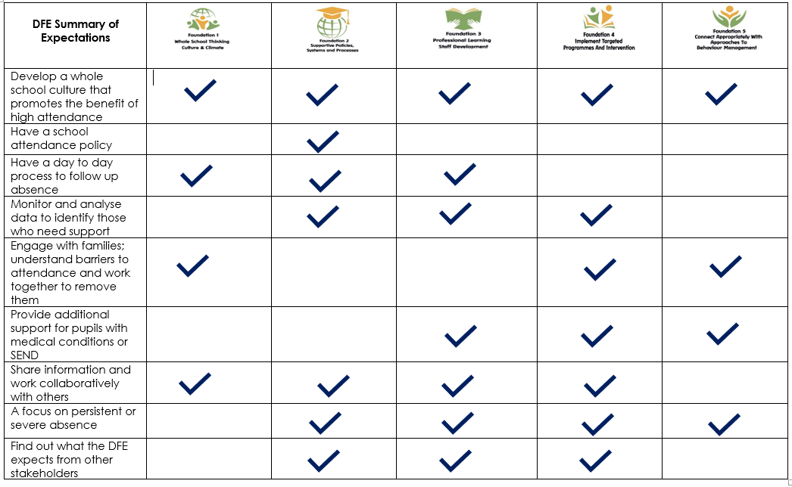

**Manor Park Primary School and Nursery will always work in partnership with our parents**

As a school we recognise that poor attendance is often an indication of difficulties in a child’s life and their lived experience. This may be related to problems at home or in school. Parents should inform the school of any difficulties or changes in circumstances that may affect their child’s attendance and or behaviour in school; for example, bereavement, divorce/separation, incidents of domestic abuse. This will help the school to identify any additional early help that may be required. Safeguarding is a priority, so concerns for any child at any time will be reported to the DSL or DDSL. We will always follow Keeping Children Safe in Education 2024 and our Child Protection Policy.

Some children are more likely to require additional support to attain good attendance. For example, children who are vulnerable, have a medical need or EHCP plan will be monitored and supported in school. We will proactively identify and follow up on a child’s non-attendance and gather information about the child.

This will result in taking early action to prevent non-attendance developing and monitoring the impact of targeted support.

The Attendance Team will initially:

* Check records, including any from other schools which the child has attended previously.
* Discuss with staff how the child is coping with the curriculum
* Speak to the Special Educational Needs Coordinator to establish whether the child is on the Special Educational needs register.
* Take into account the voice of the child and understand any difficulties, and their views on how the issue could be addressed.

Children whose attendance falls below 90% are Persistently Absent from school, where a child falls under 50% attendance the child will be classified as a Severely Absent child. Ultimately this will indicate that all intervention, and support, offered by Manor Park Primary School has not made the expected impact to improve overall attendance. Where attendance remains a concern and all other interventions and support have not made a significant impact, we will escalate with external partners**.**

**Attendance Support Map.**

We will always support children during each stage of our Attendance Support Map. If there is lack of engagement, or concerns regarding the reason for absence, we will follow the Attendance Map to ensure we prioritise a child’s learning and right to education

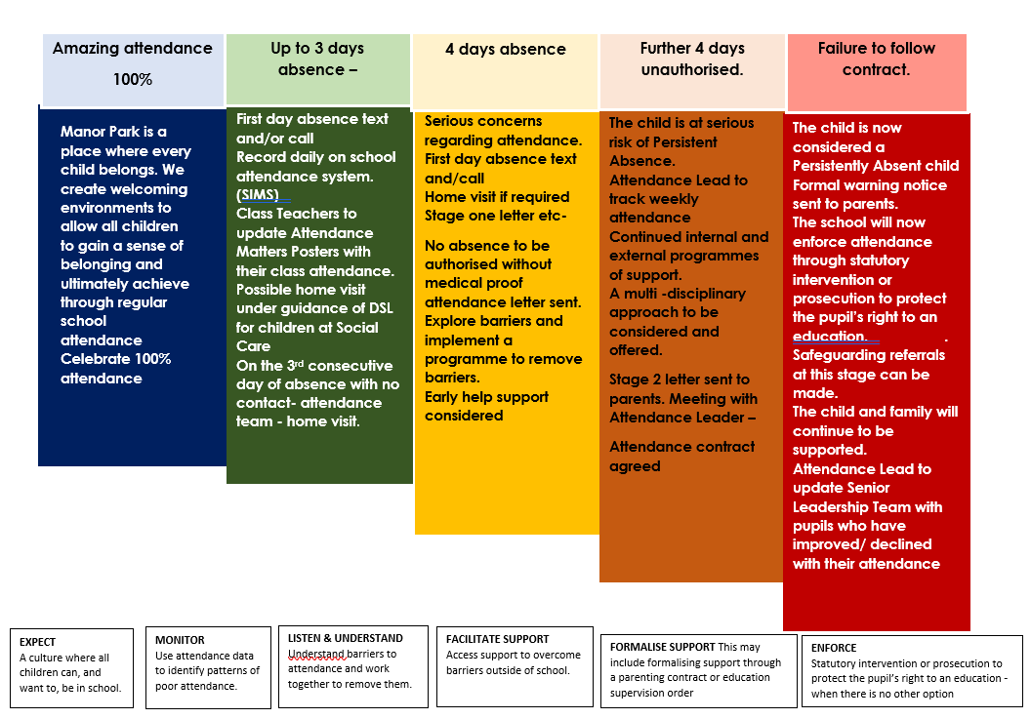

**Punctuality**

School starts at 8.50am and all children are expected to be in school for registration at 8.55am. The outside doors will be opened at 8.40am and closed at 9.00.

Children arriving after that time must come into school via the main entrance and parents/carers

must sign their child in stating the reason for lateness. The register is recorded at 9.00am and at

9.30am the register is closed. Children arriving after this time will receive an **unauthorised** absence.

If the reason for absence is medical parents are required to telephone the school office by 9.00 am on the first day of absence. When school has not been informed of the reason for absence, attempts will be made to contact a parent/carer. Failure to contact a parent/carer may result in the school contacting Education Welfare or Social Care.

**Identification & Referral**

* Attendance is monitored daily. All children with below 96% attendance are identified.
* Concerns are passed to the Attendance Team, who will review the attendance of these children and an initial letter will be sent to parents informing them that medical evidence may be requested for all further absences to be authorised.
* If the child has a further 4 unauthorised absences, parents will be invited to attend an attendance meeting at school to formulate an attendance contract to improve their child’s attendance.
* If the contract is broken, the matter will be passed to the Local Authority who may decide to impose a Fixed Penalty Notice. This will happen if all efforts to improve the situation do not appear to have worked.
* Parents who take their child out of school for an unauthorised holiday of 10 sessions or more will also be referred to Cheshire East Educational Welfare Service. Again, they may decide to impose a Fixed Penalty notice.

**Statutory Duty**

Section 7 of the Education Act 1996 states that the parent of every child of compulsory school age receive efficient full-time education suitable to their age, aptitude and ability and any special educational needs they may have, either by regular attendance at school or otherwise.

A child is of compulsory school age at the beginning of the term following their 5th birthday.

Under the Education Act 1996, the Local Authority has a statutory responsibility to ensure that parents secure education for children of compulsory school age and where necessary, use legal enforcement.

In accordance with the regulations regarding pupils’ attendance at school, Manor Park Primary School keeps an attendance register on which at the beginning of each morning and afternoon session children are marked present or absent. The marks are electronically processed and stored on the school’s central administrative system SIMS. This information is shared with the Department for Education.

**Legal Sanctions**

There are several sanctions that school can take to address the issue of non-attendance. To try and identify the reason for absence we will always talk to you first to identify the reason for absence. We will always ensure the attendance support strategy is followed, focusing on the support a child needs at each stage. However, for lack of engagement in attendance support there are sanctions that will be required to follow:

Penalty Notices will be considered when:

• A child is absent from school for the purpose of a Leave of Absence in term time and the absence has not been authorised by the school.

• A child has accumulated at least ten sessions (5 days) of unauthorised absence and further absence has occurred following written warning to improve

**Roles and Responsibilities**

**Parents**

* Parents have a legal responsibility to ensure that their children attend school regularly and punctually and stay in school for every lesson after they have registered.

• Parents should make sure that the children arrive on time, properly dressed, with the right equipment and in a fit state to benefit from the education offered to them.

• A reason should be offered for any lateness.

• They should keep requests for their child to be absent to a minimum. For example every effort should be made to make medical appointments outside of the school day.

• Parents must telephone school on the first day of absence before 9am, giving a clear reason.

* Parents should also inform the school in writing as to why their child has been absent either in the form of a letter, an email or as a note in the child’s planner.

• They need to work closely with the school and Attendance and Out of School Team’s officer to resolve any problems that may impede a child’s attendance

• With effect from September 2013 new legislation does not give any legal entitlement to parents to take their children on holiday during term time.

• Any application for leave of absence can only be in exceptional circumstances. This request must be made in writing to the Headteacher. They must be satisfied that the circumstances warrant the granting of leave of absence and may require written evidence. ‘Exceptional circumstances’ means that the parent must put the case as to why their child should be treated differently to the norm.

**Appointments**

As far as possible, parents will attempt to book medical and dental appointments outside of school hours. Where this is not possible, a note and appointment card will be sent to the school office. If the appointment requires the pupil to leave during the school day, they will be signed out at the school office by a parent.

**Children:**

* All children should aim to have an excellent attendance and punctuality record for which there will be appropriate rewards.
* All children are expected to be on the school site on time and ready to learn.
* Children who arrive at school late must enter school via the office so their attendance can be recorded
* Children must not leave the school without permission. This will be seen as a safeguarding concern as well as a Health and Safety concern

**Class Teacher**

The Class Teachers are the key staff members in promoting regular punctual attendance. They

will:

* provide a good example by always being punctual to class and meeting being in the classroom before the children so they are there to provide a welcoming environment;
* keep an accurate and up-to-date register of attendance;
* follow the Attendance Policy procedures when dealing with absences and punctuality;
* ensure that children and young people are aware of the importance of the school attendance target
* build a welcoming atmosphere in the classroom and provide support as necessary when children return after an absence.

**Attendance team.**

The attendance team take responsibility for monitoring the attendance of children and regularly promote the importance of attendance and punctuality. They will:

* ensure that their team is aware of their responsibilities with respect to promoting attendance and punctuality and adherence to the attendance policy and procedures;
* ensure that rewards and sanctions for attendance and punctuality follow agreed procedures and align to the School Behaviour and Attendance Policy;
* monitor and track the attendance of vulnerable groups;
* monitor the attendance of individual classes
* liaise effectively with the Attendance Leader and work together on ensuring that appropriate action is taken in the management of absenteeism and poor punctuality;
* have attendance as a regular item during pastoral meetings;
* ensure contact is made with parents of poor attendees – always offering support before sanction